**Data validation**

**Practice 1:**

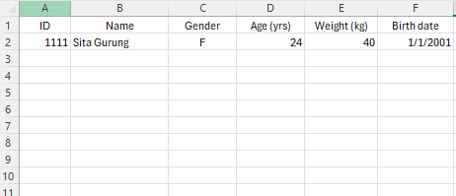

Data validation rules:

* ID should be 4 characters long.
* Age should be a whole number and positive.
* Weight should be 40-60 kg if female, 50-70 kg if male.
* Birth date should be greater than or equal to 1/1/2000.
* Gender column should have a dropdown list for “M” or “F” choice.

**Practice 2:**

* Circle total with wrong calculation.

**Conditional formatting**

**Practice 3:**

* Highlight countries with green color which includes “ind” text.
* For “ele_rural” column, highlight the cells according to (0-blue, 50-white, 100-green).
* Highlight the row with gray color where the country’s starting character ends.
* For “ele_total”, insert up arrow for values greater than or equal to 67, down arrow for values less than or equal to 33, and horizontal line otherwise.
* Change font color to red and make bold “tfec” where “tot_ele” is greater than 10% value of “tfec”.

**Protecting worksheets and workbook with passwords**

**Practice 4:**

* To password protect a workbook, go to **File > Info > Encrypt with Password** and set a password (e.g., nsonso).
* Protect “**sheet_protection**” sheet and only allow to change cells B3:B5, B7:B8. Also, hide the formula in B6.

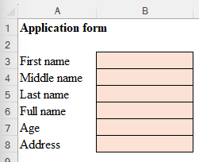

**Sharing workbooks for collaborative editing**

**Practice 5:**

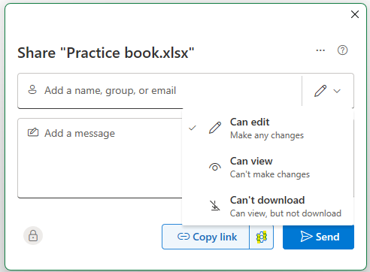

* Share the workbook with a specific user (user should have Microsoft id).
* Share the workbook with edit right to anyone. And set password “nsonso” to access the file.

* Demonstrate collaborative editing with Web and Desktop office app.

**Versioning in excel**

**Practice 6:**

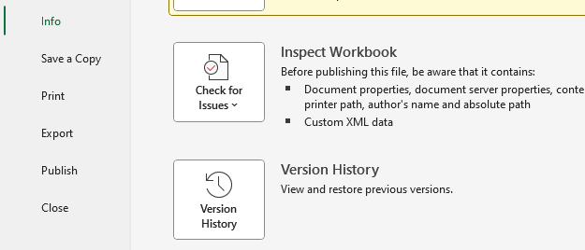

* Upload excel file to the onedrive cloud.
* Make changes to the workbook.
* Version history will be saved automatically.
* Now, you can view and restore previous versions automatically.

*Versioning functionality can also be achieved with Google Drive.*